* Create a docker image
* Which has Ubuntu, java, git ,tomcat images associated
* Expose 8080
* Image with Env Param and Without Env Param
* Start the container in interactive mode/attach
* Volumes should be used to deploy addressbook.war file as well
* Able to show java,git are running – exec command
* Create CI/CD pipeline to start and deploy Docker Container

**Created new project and dockerfiles inside it**

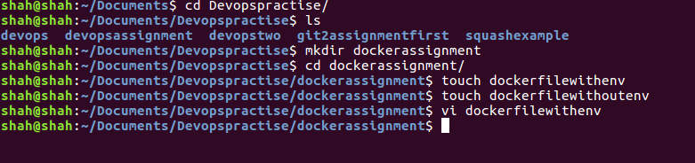

**Wrote final version of dockerfile for (with env) after making many changes to it**

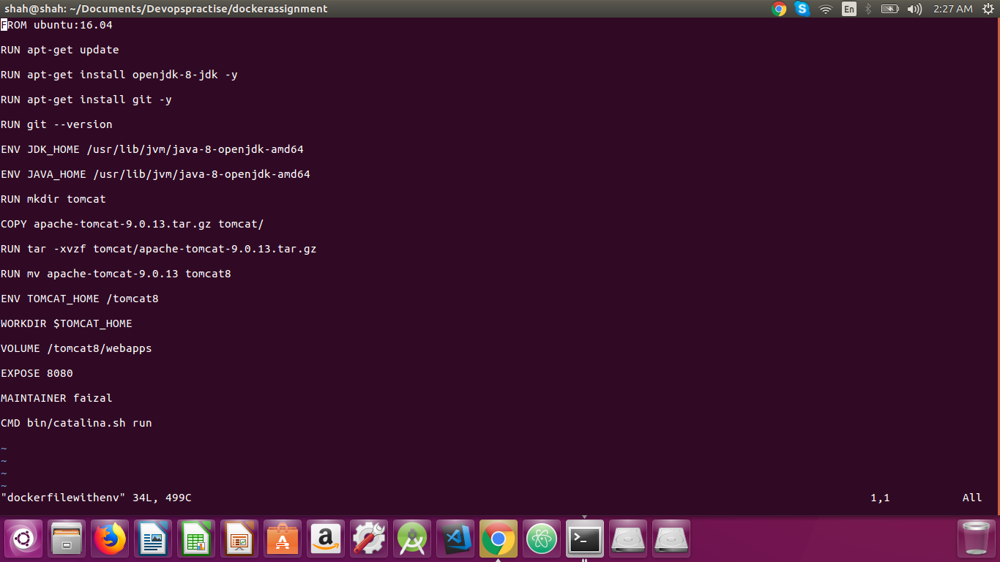

**Building image from dockerfilewithenv and tagging it as image name dockerwithenv**

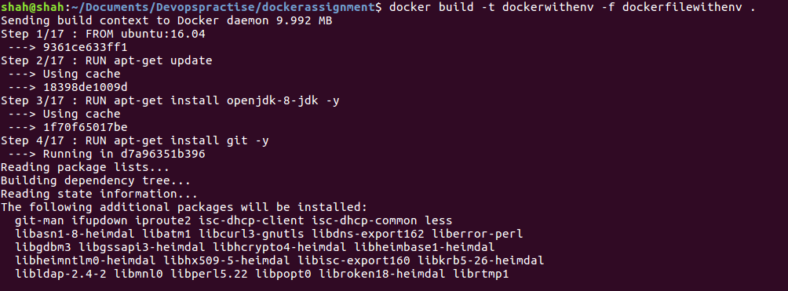

**Successfully build image**

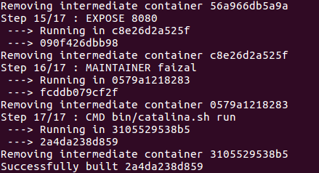

**Can be viewable using docker images command**



**Running container using last built image with volume, port, name as options inside docker run command syntax**

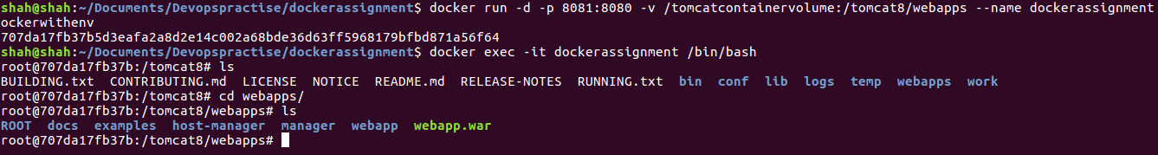

**Created shared dir volume on host machine with some code in it**



**Successfully runned with localhost:8081 as defined in run command**

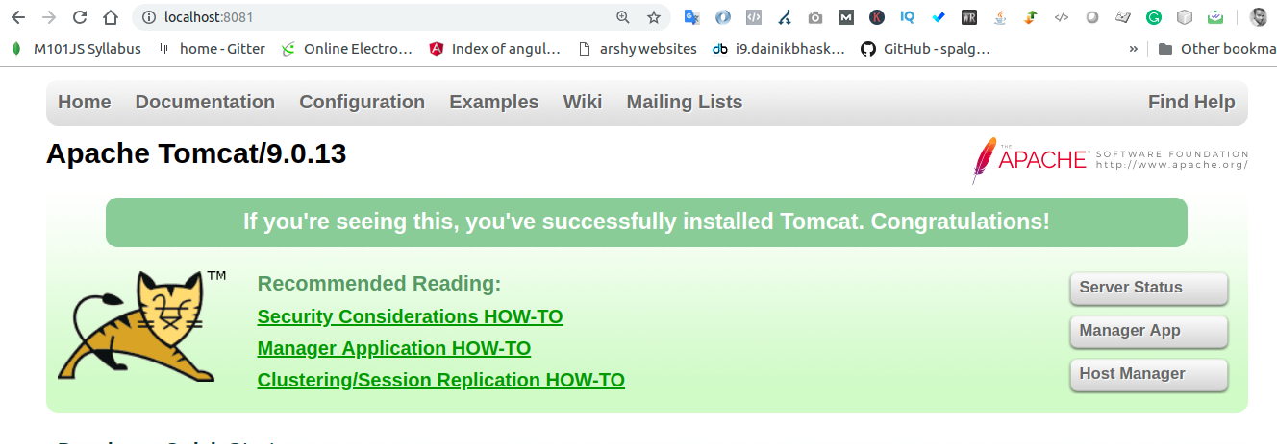

**App is running which is shared via shared dir volume**

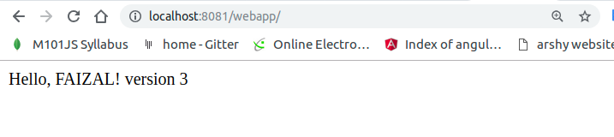

**Git & java commands can be runned via docker exec command syntax**





**New dockerfile created for same task but without env**

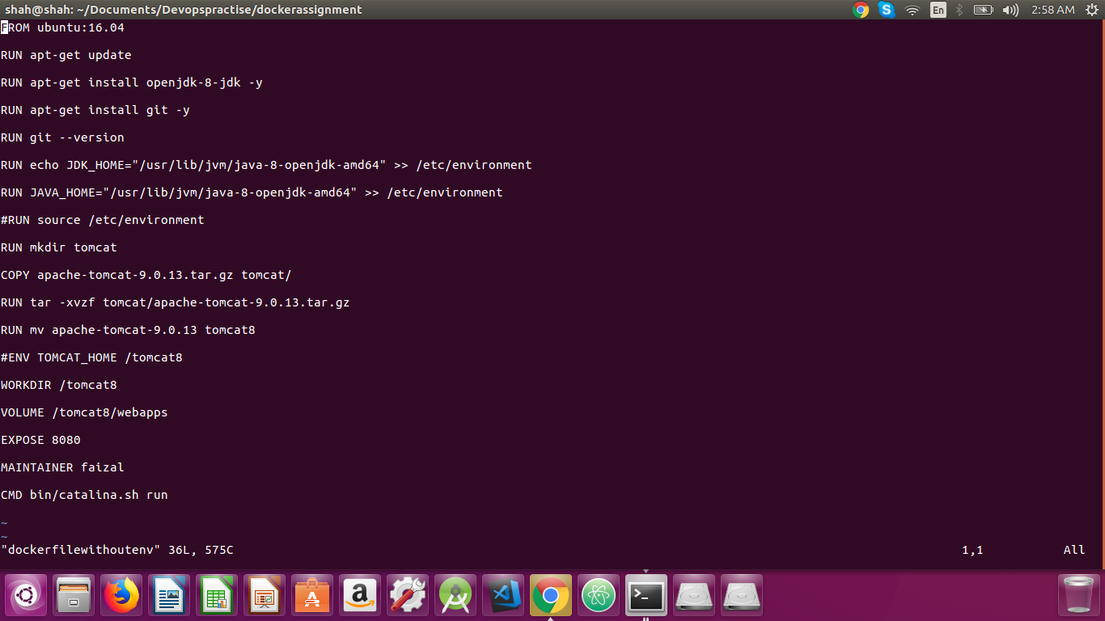

**Building image from dockerfilewithoutenv file and tagging it as dockerwithouenv as its image name**

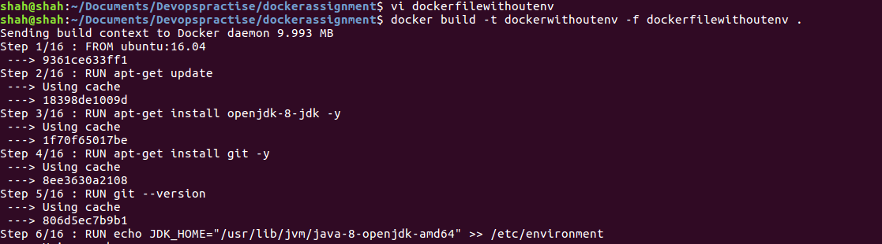

**Successfully build image**

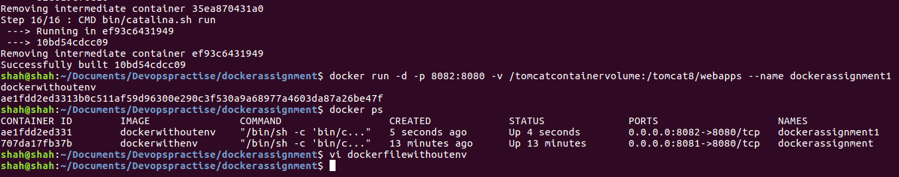

**Running tomcat on localhost:8082 as given in docker run command**

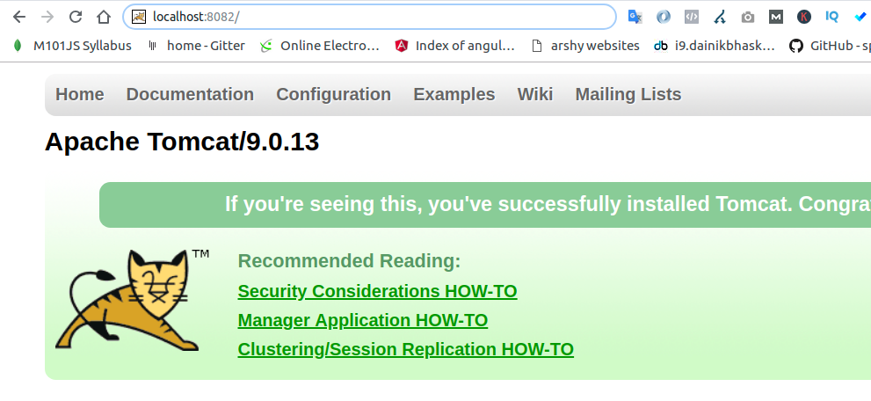

**App is running which is shared via shared dir volum**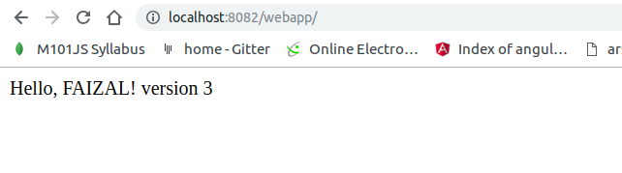

* Create CI/CD pipeline to start and deploy Docker Container

**we will do it later as instructed and after understanding it from you.**